Key Models
1. GPT (Generative Pre-trained Transformer)
Overview: GPT is a language model developed by OpenAI. It uses the Transformer architecture to understand and generate human-like text.
Key Features:
- Pre-trained on large text datasets.
- Fine-tuned for tasks like translation, summarization, and Q&A.
- Capable of zero-shot and few-shot learning.
Architecture: Based on the Transformer model, which uses self-attention to process sequences in parallel.
Training: Two stages:
- Pre-training: On massive text corpora using unsupervised learning (predict next token).
- Fine-tuning: On specific tasks with supervised learning or reinforcement learning (e.g., RLHF).

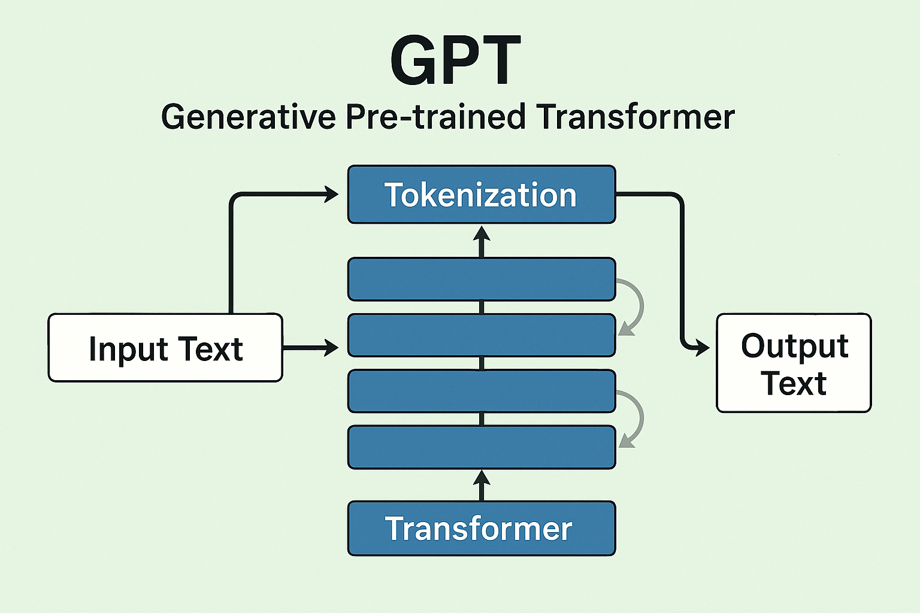

2. DALL·E
Overview: DALL·E is a model that generates images from textual descriptions. It combines NLP and computer vision.
Key Features:
- Text-to-image generation.
- Can create imaginative and surreal visuals.
- Uses a variant of the Transformer architecture.
Purpose: Text-to-image generation using a combination of NLP and image synthesis.

Core Idea: Converts text prompts into image embeddings and then decodes them into images.

Architecture: Uses a Transformer for text encoding and a VQ-VAE or diffusion-based decoder for image generation.

Applications: Creative design, concept art, marketing visuals.

Challenges: Prompt sensitivity, ethical concerns (deepfakes, misuse).

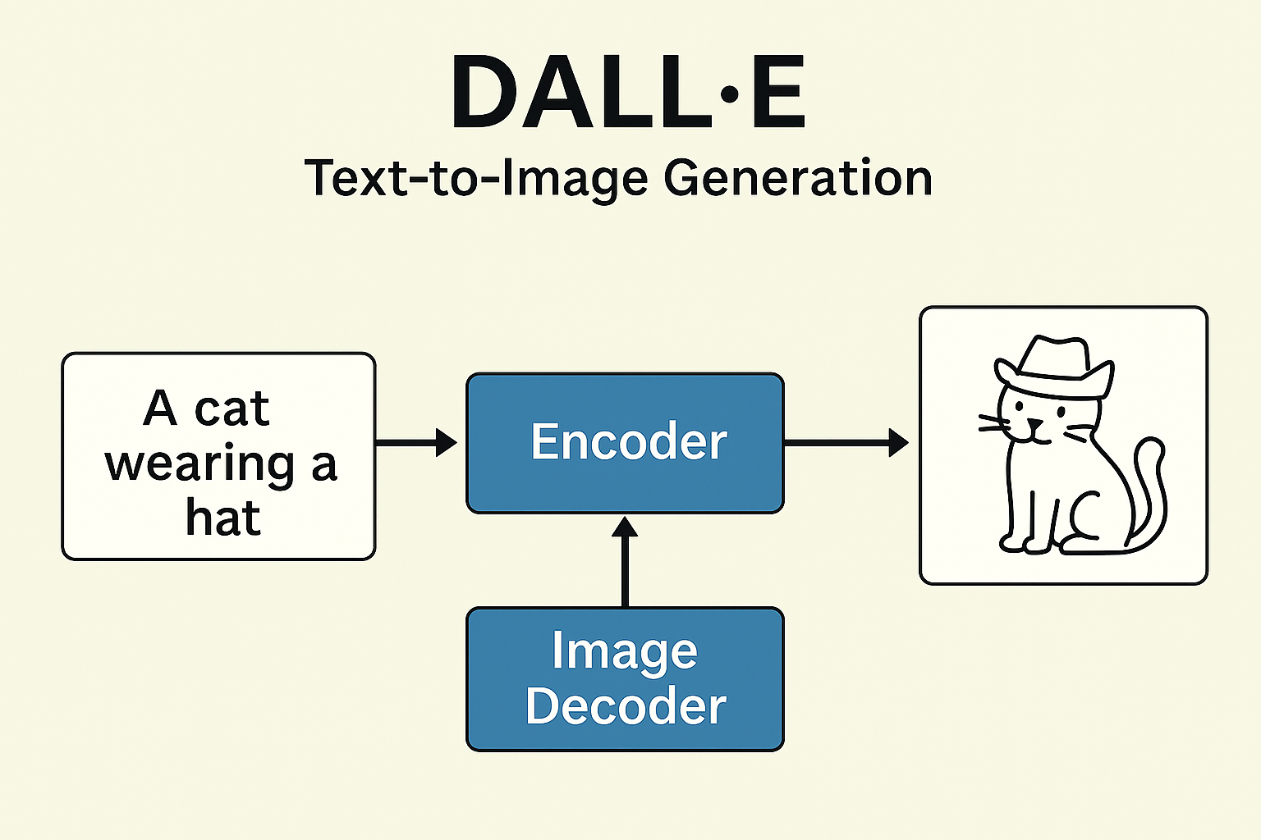

3. Codex
Overview: Codex is a descendant of GPT, trained specifically on code. It powers tools like GitHub Copilot.
Key Features:
- Converts natural language to code.
- Supports multiple programming languages.
- Useful for code completion and generation.
Specialization: Converts natural language into code.

Training Data: Large datasets of public code repositories and natural language.

Capabilities: Code completion, bug fixing, generating entire programs from descriptions.

Applications: IDE integration (e.g., GitHub Copilot), automation of repetitive coding tasks.

Limitations: May produce insecure or inefficient code, requires human review.

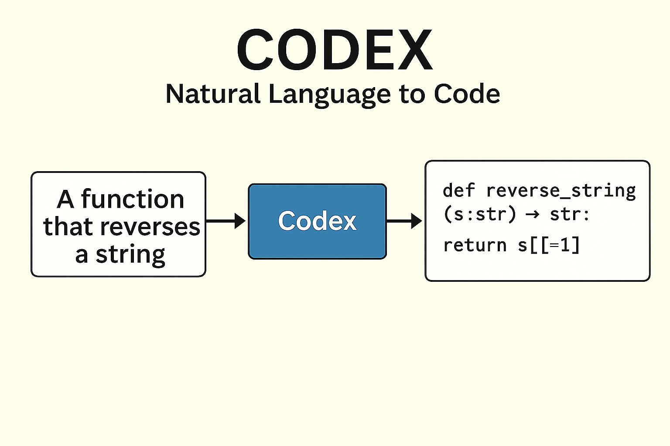

4. Stable Diffusion
Overview: Stable Diffusion is a text-to-image model based on diffusion processes. It’s open-source and widely used for creative tasks.
Key Features:
- Latent diffusion model.
- Generates high-quality images from text.
- Efficient and customizable.
Type: Latent diffusion model for text-to-image generation.

Process:
- Start with random noise in latent space.
- Apply iterative denoising steps guided by text embeddings.

Advantages: Open-source, efficient, customizable.

Applications: Art generation, product design, concept visualization.

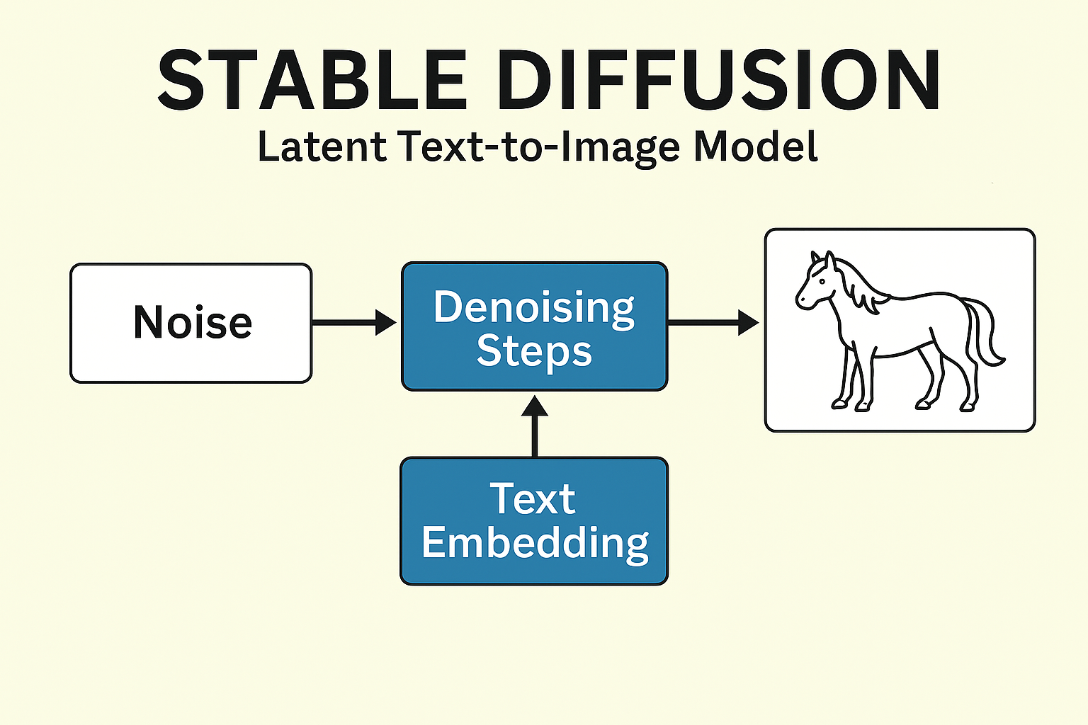

5. Diffusion Models
Overview: Diffusion models generate data by reversing a noise process. They are used in image synthesis and other generative tasks.
Key Features:
- Gradual noise addition and removal.
- High-quality image generation.
- Stable training compared to GANs.
Concept: Learn to reverse a diffusion process that gradually adds noise to data.

Forward Process: Add Gaussian noise to an image until it becomes pure noise.

Reverse Process: Learn to denoise step by step to reconstruct the image.

Strengths: High-quality, diverse outputs; stable training compared to GANs.

Weaknesses: Computationally expensive, slow generation.

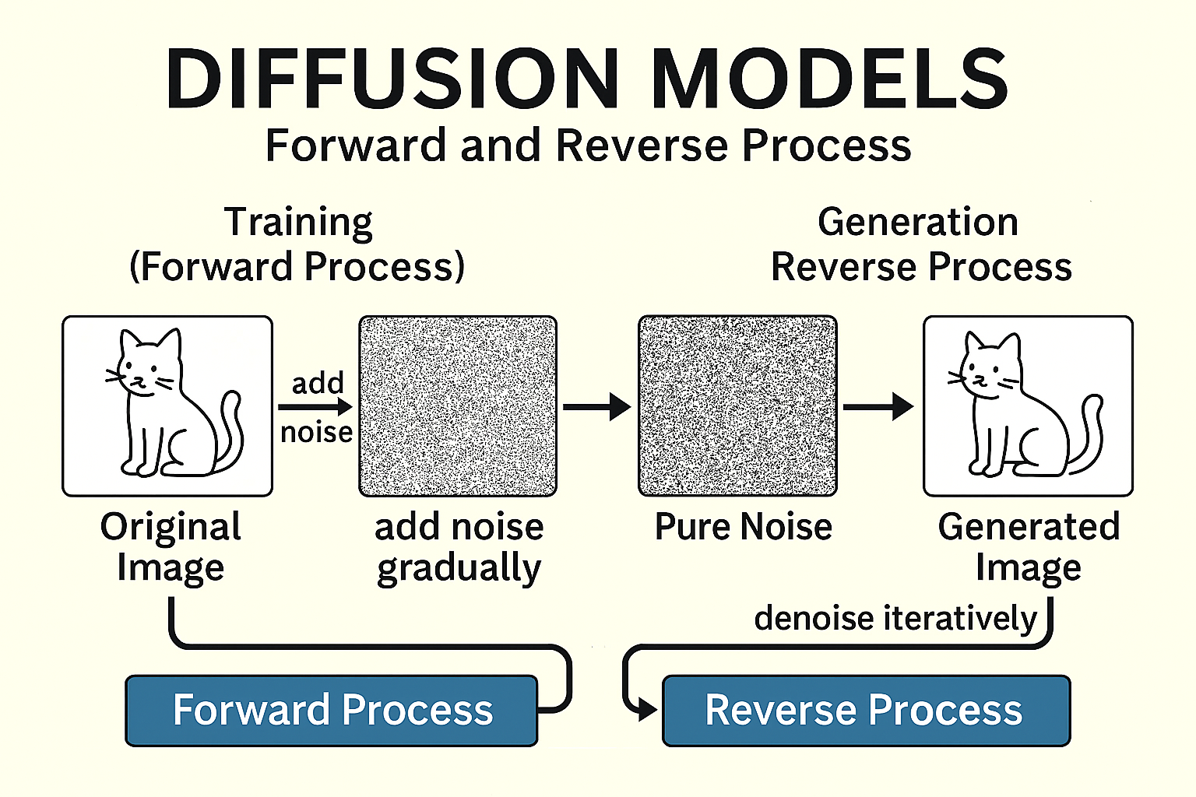

6. GANs (Generative Adversarial Networks)
Overview: GANs consist of two networks: a generator and a discriminator. They compete to improve the quality of generated data.
Key Features:
- Generator creates fake data.
- Discriminator evaluates authenticity.
- Used in image generation, video synthesis, etc.
Structure: Two networks:
- Generator: Creates fake samples.
- Discriminator: Distinguishes real from fake.

Training: Adversarial game where both networks improve iteratively.

Applications: Image synthesis, video generation, style transfer.

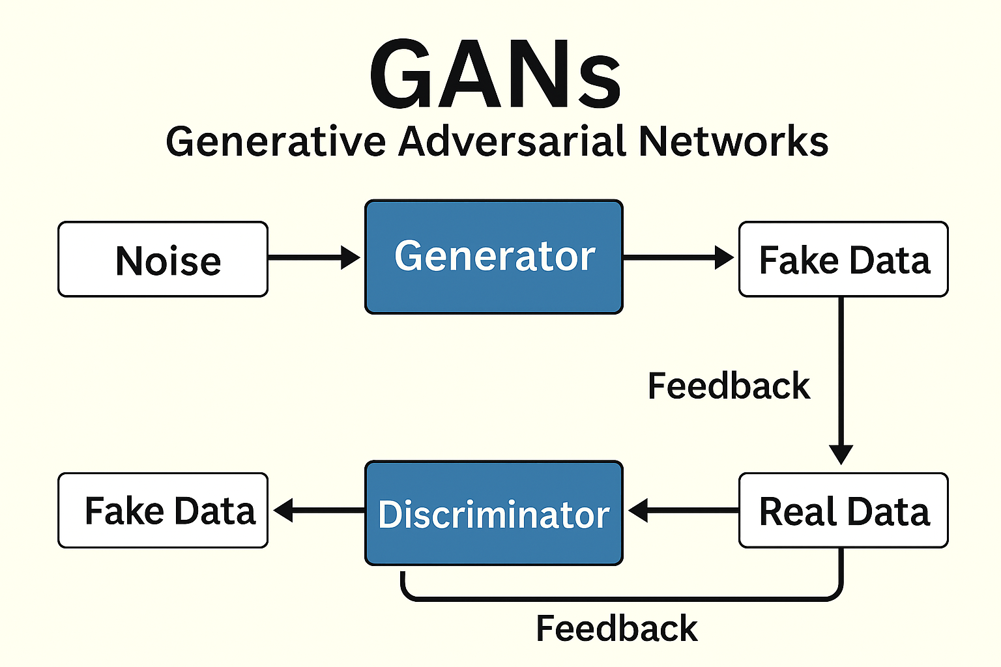

7. Transformer Architecture
Overview: Transformers use self-attention to process sequences. They are the backbone of models like GPT, BERT, and DALL·E.
Key Features:
- Scalable and parallelizable.
- Handles long-range dependencies.
- Basis for most modern NLP models.
Key Innovation: Self-attention mechanism that allows models to weigh the importance of different tokens in a sequence.

Components:
- Encoder: Processes input sequences.
- Decoder: Generates output sequences.

Advantages: Parallel processing, handles long dependencies, scalable.

